Berriasian Working Group meeting - Kroměříž 2018
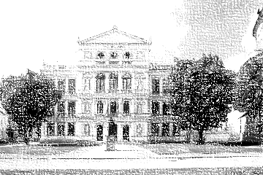
First circular

When?
May 14th to 18th 2018

Where?
The meeting will take place in an aula of Judical Academy
Masarykovo nám. 183, Kroměříž

How to get there?
Closest airports: Brno (2hours by train or bus)
International airports: Praha, Bratislava, Katowice or Wien (4hours by train or bus)
Train station in Kroměříž
Direct buslines from Brno
The organizers can pick sb. up from Prague airport the day or two before.

Programme:
Registration May 14th 13:00 to 17:00
Ice-breaker party May 14th 18:00
Talks 15th -16th
Excursion to Kurovice 16th morning
Excursion to Stramberk 17th all day long
Discussion over possible GSSPs 16th afternoon

Accommodation:
Many possibilities of accommodation on Velké náměstí (Giant Square).
Organizers can book very cheap student accommodation in the school dormitories in the 2 or 3 bed rooms.

Fee:
Still counting

Organization committee:

Program and official invitations - Petr Schnabl schnabl@gli.cas.cz
Registration and payment (+ accommodation in dormitories)
Šimon Kdýr kdyr@gli.cas.cz + Kristýna Čížková cizkovak@gli.cas.cz

Excursion to Kurovice - Miroslav Bubík, Martin Košťák
Excursion to Stramberk - Petr Skupien, Zdeněk Vašíček

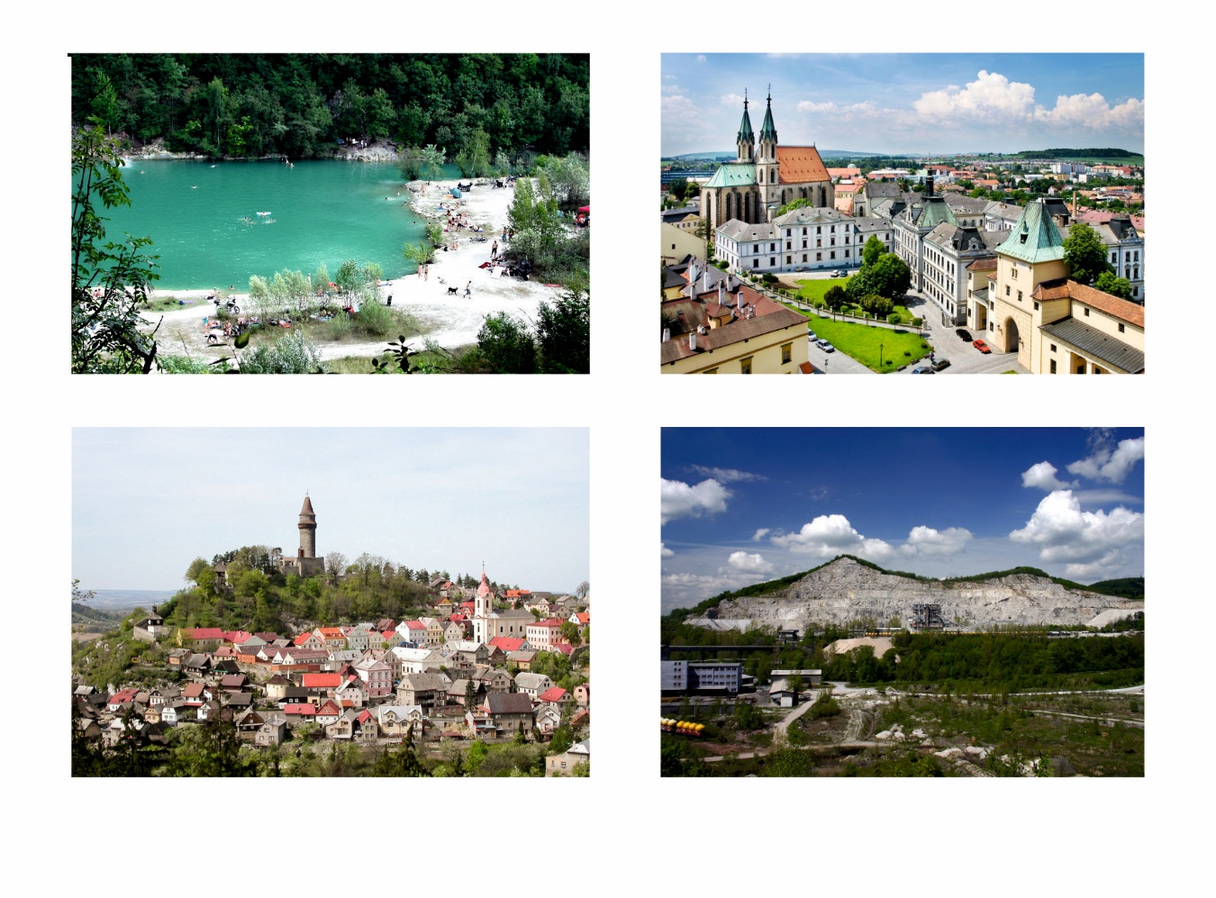
TL: Kurovice quarry TR: City of Kroměříž
BL: Town of Štramberk BR: Kotouč quarry

