Registration form

Berriasian Working Group meeting

Kromeriz, May 14th – 18th 2018
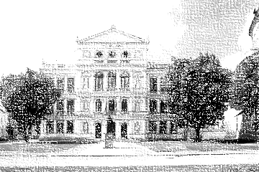

Please send completed registration form by email to: hladikova@gli.cas.cz

Name, title:

Institution:

Contact address:

Telephone:

E-mail:

I would like to present: poster / lecture / both

Lecture title:
Authors:

Poster title:
Authors:

Field trip: yes / no

Meal: vegetarian / non-vegetarian

Accommodation (if possible) yes / no

Special requirements: …

